**Access AWS by 3 ways**

* User name & password
* Access ASW console via AWS CLI need to install the software.

1. Check the software is availabke or not by below command

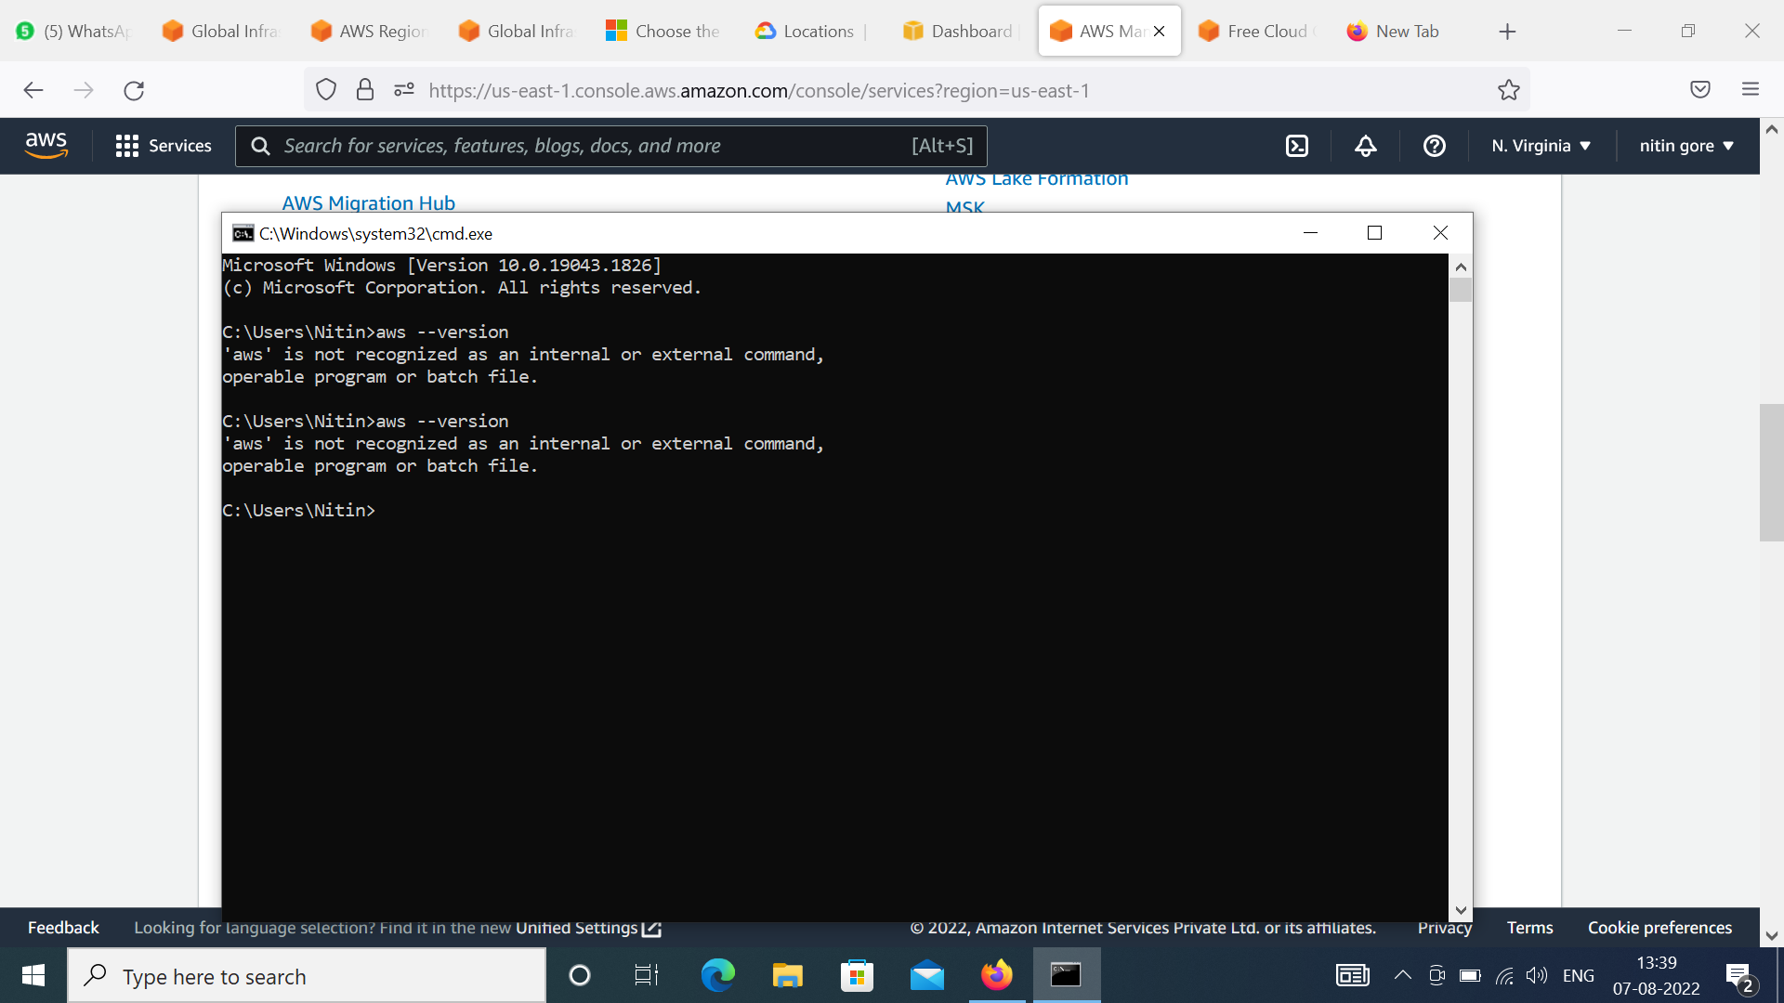

1. Search on google

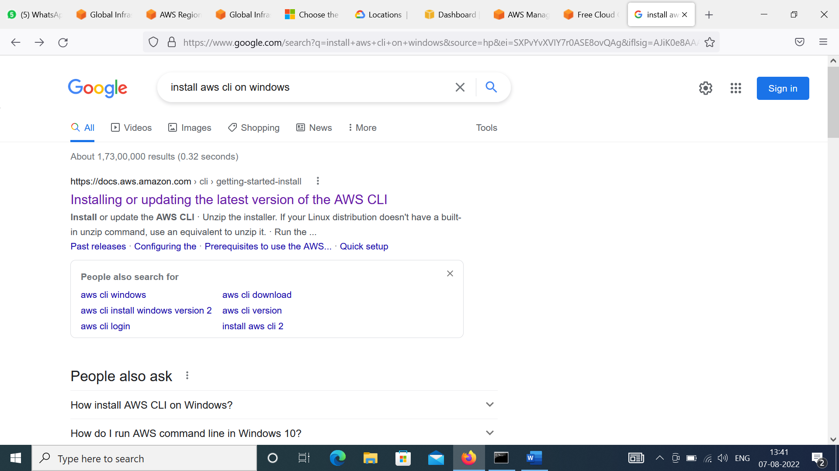

Install the software

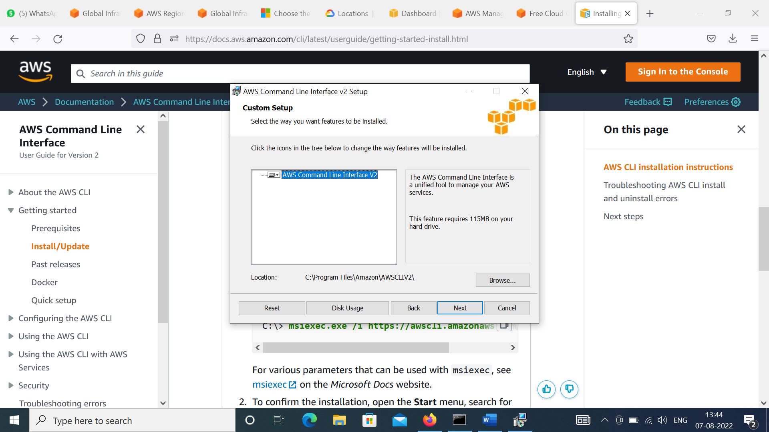

After instillation check command

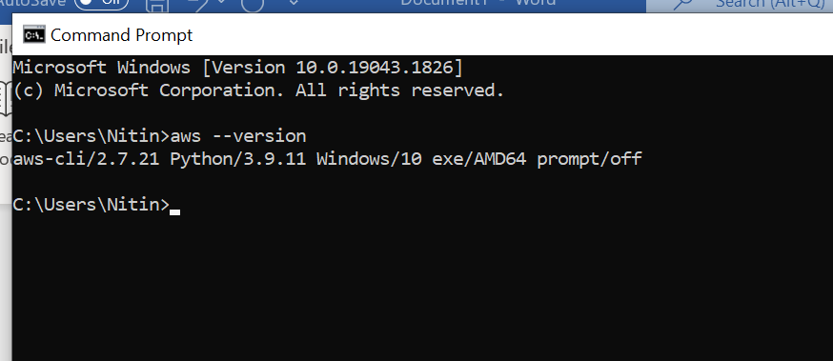

Then do below for Access key 🡪 Open the IAM tab

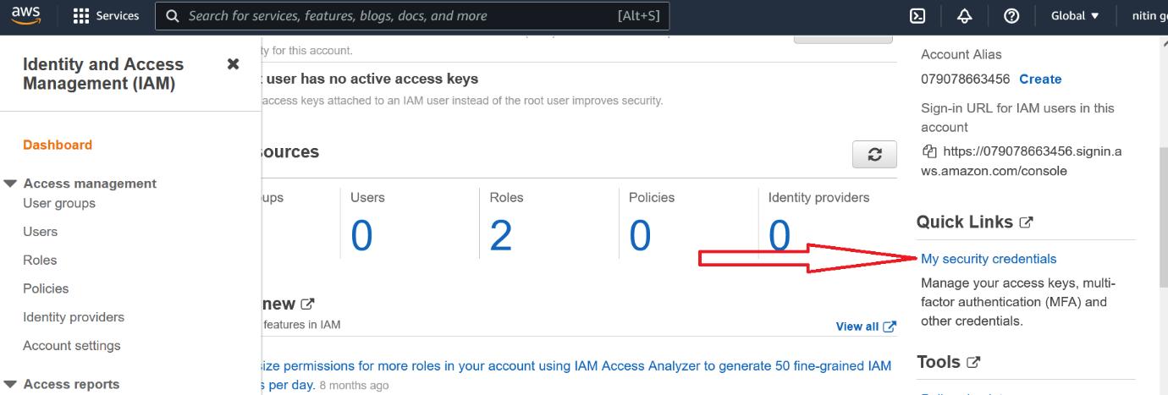

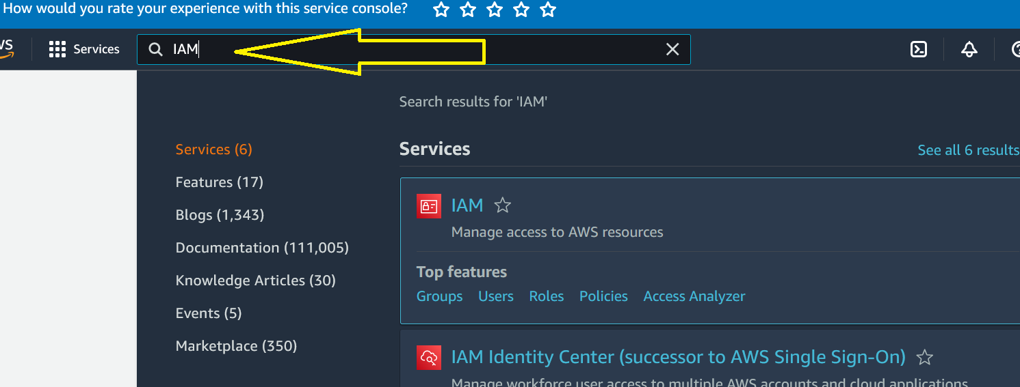



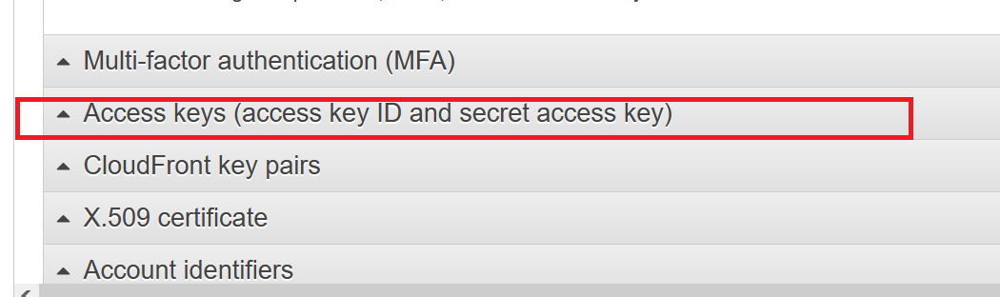

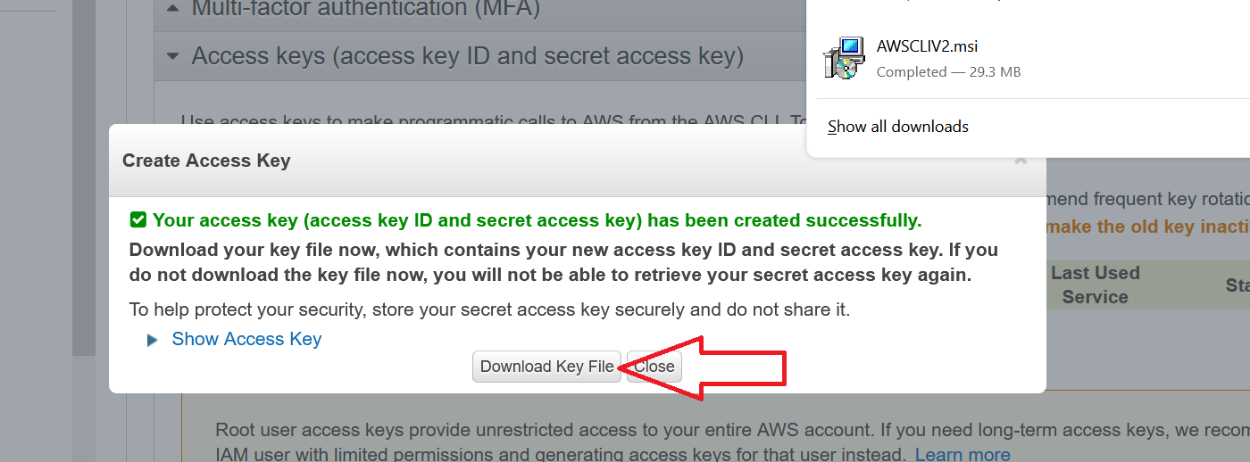

Now go to CMD

Type command 🡪 aws configure

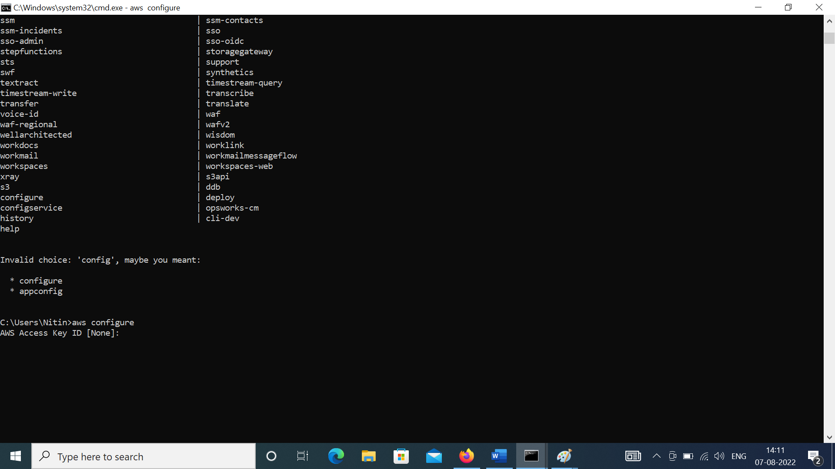

Put the credentials from Key which you download above

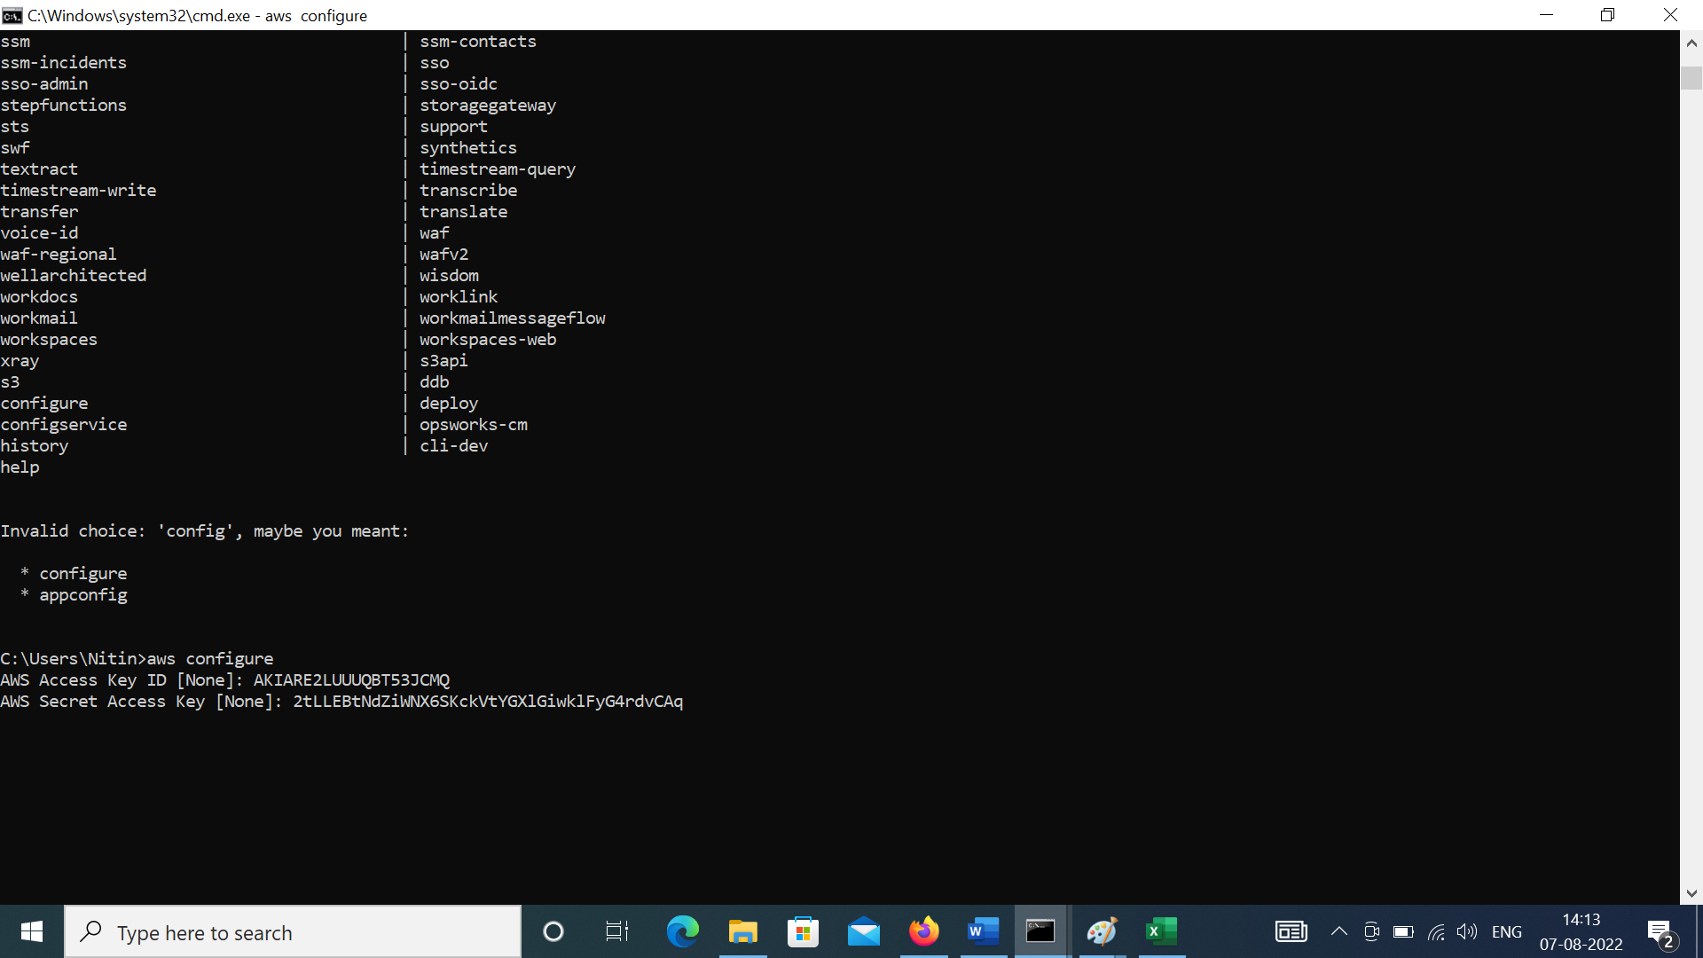

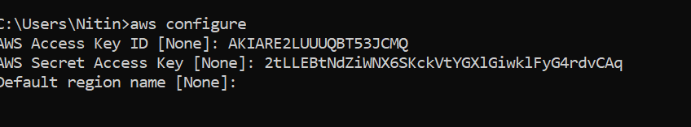

For Region go to google and type aws us east (northern Virginia) region.

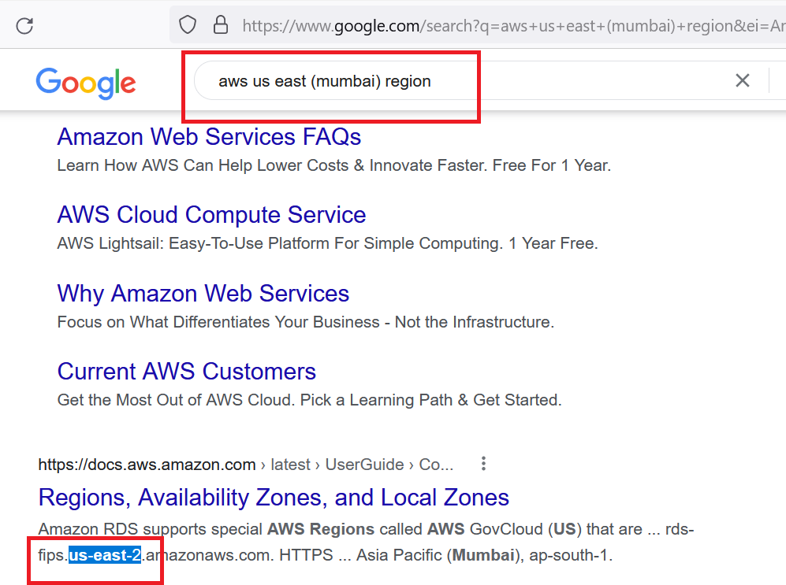

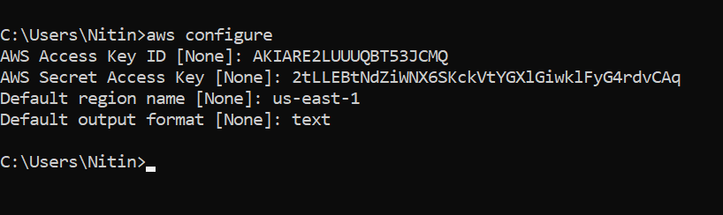

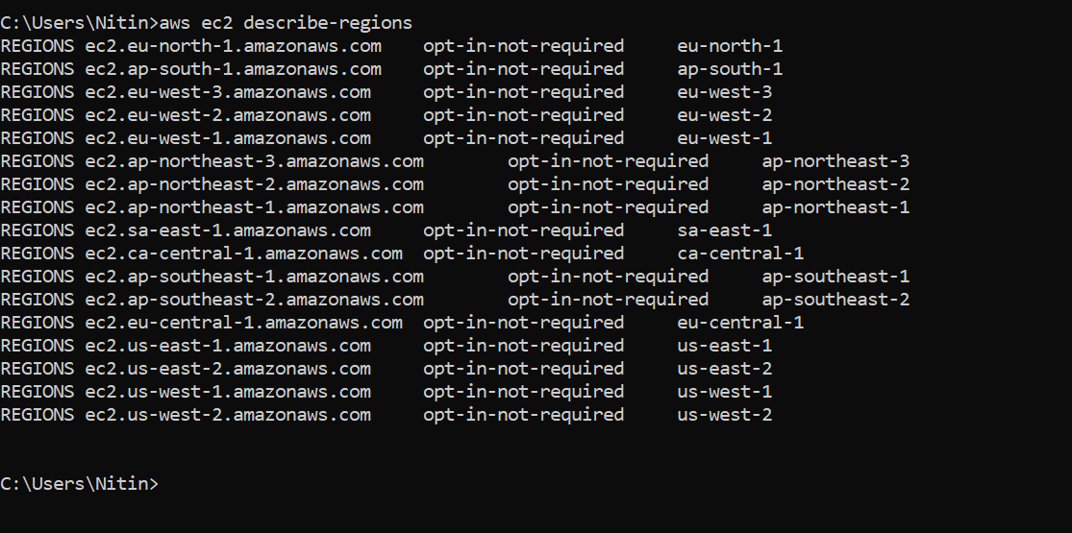

Secret key & configuration is save on below location, once you do your work delete the path files

